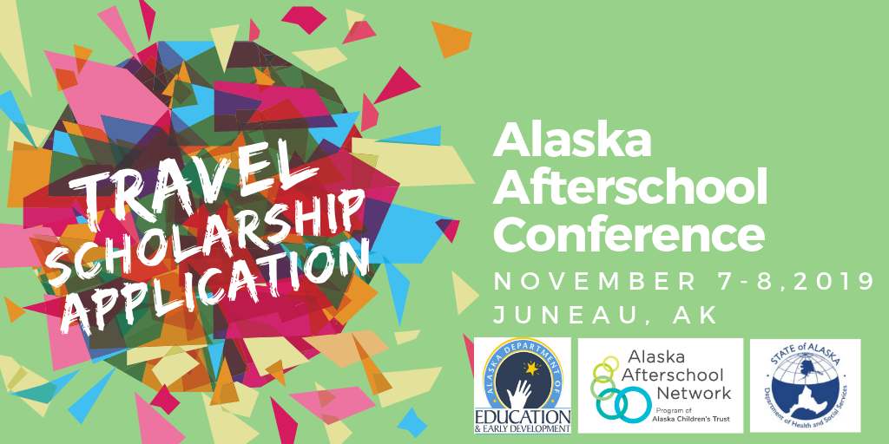
Alaska Afterschool Conference
Travel Scholarship Application
Deadline to Apply: September 6, 2019

Travel scholarships* are to assist Alaska Afterschool Network partners with travel to the Alaska Afterschool Conference, November 7-8, 2019, in Juneau, Alaska. 21st Century Community Learning Center grantees are not eligible to apply.
Scholarships are intended to cover travel cost (airfare, mileage) associated with travel to and from the conference. Scholarship recipients are asked to cover additional expenses, such as registration, per diem, and hotel accommodations. Individuals receiving scholarships are expected to attend the entire two days of the conference while in Anchorage, and to represent the Alaska Afterschool Network well.

Conference registration and lodging information is available at our website: https://www.akafterschool.org/alaska-afterschool-conference
Please return completed application form to:
Thomas Azzarella
Director of the Alaska Afterschool Network
Email: tazzarella@akafterschool.org
Phone: 907-248-7371
Travel Scholarship Application Form

Applicant Information

Name as it appears on ID: | Enter Info Here
Date of Birth: | Enter Info Here
Position: | Enter Info Here
Email Address: | Enter Info Here
Cell Number: | Enter Info Here
Program Information
Name of Agency & Program | Enter Info Here
Description of Program (i.e. type of programming, number of youth served, etc.) | Enter Info Here
Location of Program: | Enter Info Here
Annual Operating Budget: (required) | Enter Info Here
Scholarship Information
Pease explain your need for the scholarship: | Enter Info Here
Why are you interested in attending the Alaska Afterschool Conference? | Enter Info Here
What is your plan for incorporating and sharing knowledge gained at this conference into your program? | Enter Info Here
If we have more scholarship requests than funding, would your organization be willing/able to cover some of the airfare? | Enter Info Here

Please contact Thomas Azzarella, Director of the Alaska Afterschool Network, if your program is unable to cover additional expenses, such as registration, per diem, or hotel accommodations. Email: tazzarella@akafterschool.org Phone: 907-248-7371
*All scholarship funds are provided by the Alaska Afterschool Network.

